DR. D. A. PERLEY ELEMENTARY SCHOOL

Primary School Supplies
(Kindergarten to Grade 3)

Dear Families of Primary (K-Grade 3) Students,

We know that families may be struggling due to the rising cost of living. Perley School is excited to share that we are able to cover the cost of school supplies for any/all primary students for the 2025-26 school year, out of an Affordability Fund. The supplies have been bulk ordered by the school based on teacher lists, so your child will have what they need come September.

Please let the school know if you do NOT want your child(ren) to be included. If you choose to pay for your child’s school supplies, $50.00 can be paid by cash or cheque, the first week of school with your child’s classroom teacher.
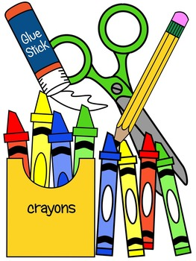
The Agendas will be at a cost to parents
for $7.00 at the beginning of the school
year in September.

